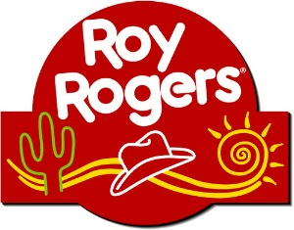

Please come out and support Potomac Heights Volunteer Fire Department & Rescue Squad by purchasing a delicious meal! A portion of all sales between 5pm-8pm will be donated to our department.

Tuesday, May 21, 2019
5pm - 8pm
6370 Crain Highway, LaPlata, MD 20646

Thank you for your support!

